To use Lexia Reading Core5® at home.
- Have your child find their Clever app on their Ipad. (Blue background with a block letter C)
- Have your child scan their Clever badge to login. If the QR code option is not present they can also login using their school lunch number and six digit birthday. 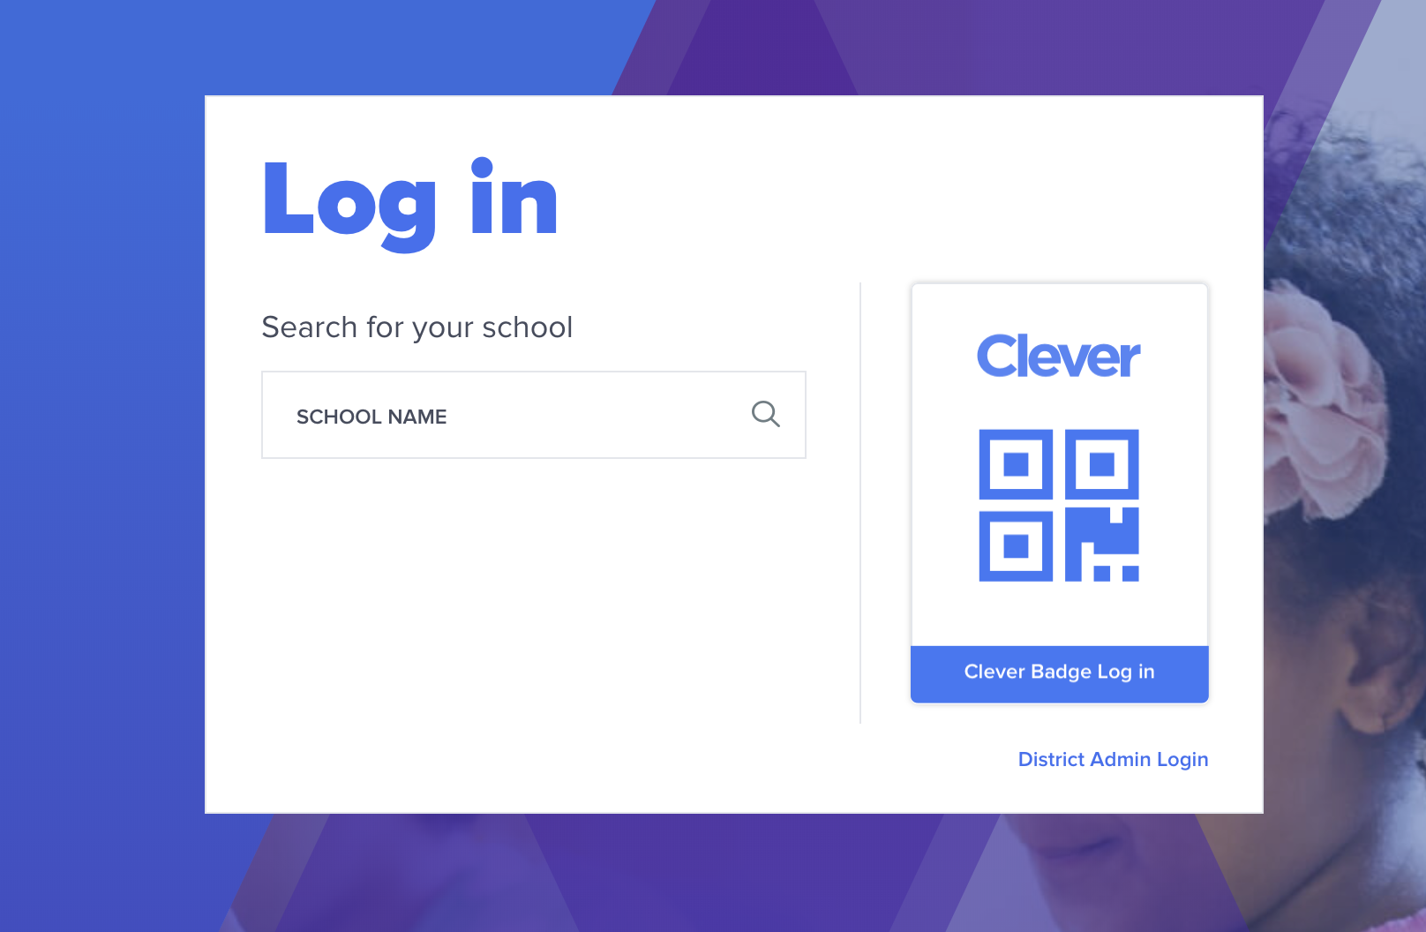
- Once they have logged in have your child click on the Lexia Core 5 app. (It’s light blue with a globe)
- The opening page shows how many minutes your child has gotten while using the program and how many units.
The first circle shows the number of minutes completed and the second circle shows the number of units.
- Your child should be working on Lexia for about 15 minutes a day. Included is a sheet that your child should be familiar with to keep track of their minute and unit usage each day. At the top it has their minute and unit goal for the week.
- ****It is important that your child works without any help while using the Lexia app. All of the work your child does at home is recorded and reported to school. This way, teachers can see when help is needed and provide additional instruction at school. If your child is struggling with a concept I will contact you through class dojo with what steps to take.
- Lexia also has an off line portion that is called Skill Builders. Your child should be very familiar with these and they can do 2-4 pages a day after doing their minutes on the app.

